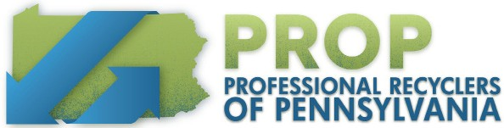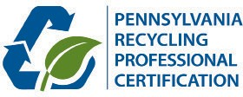

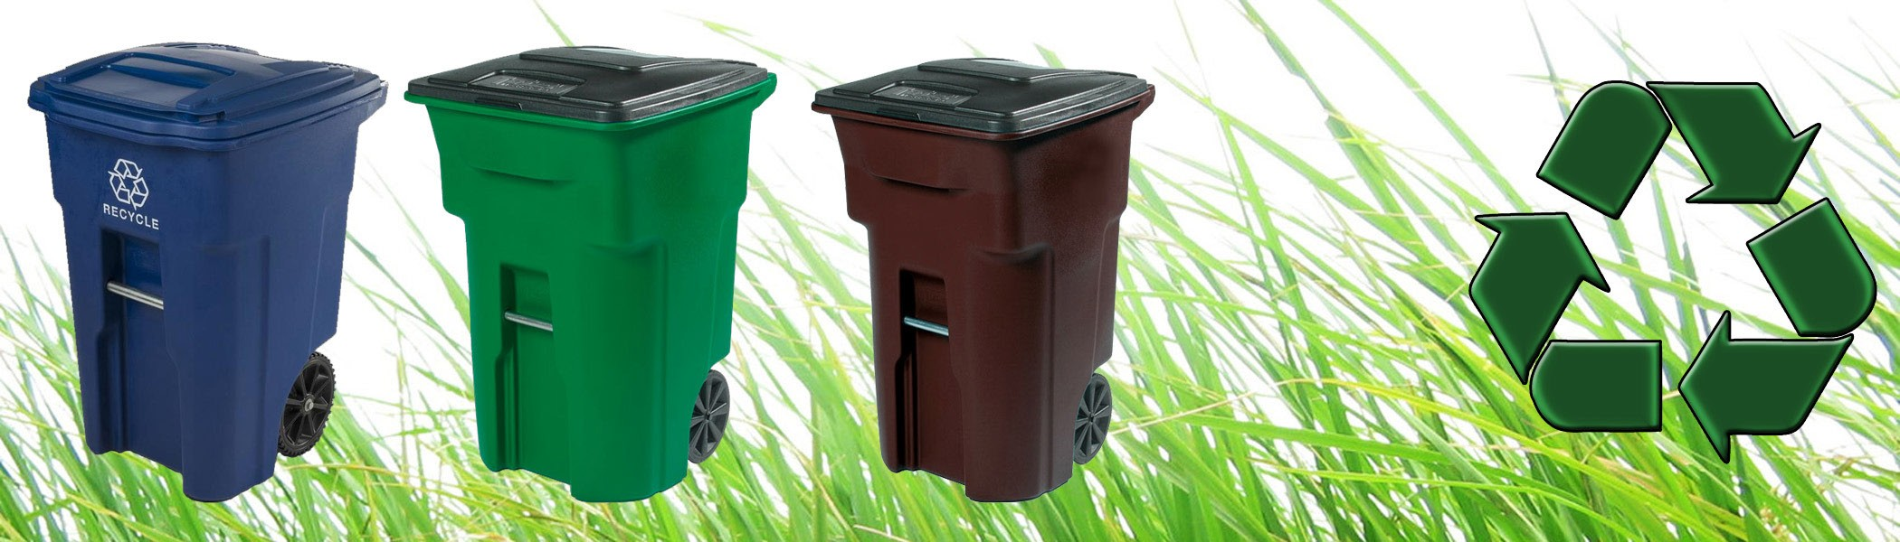
Recycling 101: Practice & Theory | 1.4 CEU

Class Location & Details

Date:
October 16-17, 2024
Time:
9:00 am - 4:00 pm (both days)
Class Location:

TBD

Registration Fee:
$505 Member
$675 Non-Members

Overnight Accommodations

TBD
Course Overview
This two-day class is the core course and the first step in earning the Recycling Professional Certification. Whether initiating a new recycling program, maintaining and improving a current program, or starting
a new position, a recycling professional can expect to be met with a variety of tasks and challenges.

This course will help both beginner and experienced coordinators develop and improve the knowledge and skills needed to implement and sustain a successful recycling program from the ground up for beginning or experienced coordinators, solid waste managers, or others in related fields. Upon completion of this course, participants will receive a Penn State certificate verifying the 1.4 CEUs earned toward Recycling Professional Certification.

Who Should Attend
Municipal, county, state, and recycling and waste professionals from the commercial, public and private industries who are interested
in recycling and those interested in obtaining or maintaining their certification.

Questions
For additional information, please contact:
Marcy Robey: mrobey@proprecycles.org | 717-441-6049
Register online at www.proprecycles.org

Professional Recyclers of Pennsylvania | www.proprecycles.org | 717.441.6049

