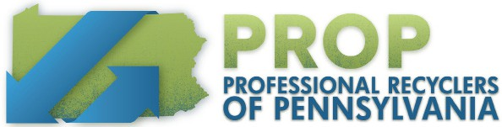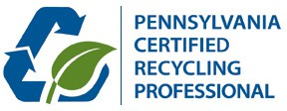

Recycling 105: Establishing & Enhancing a Program | .35 CEU Recycling 430: Buying & Using Recycled | .35 CEU

Recycling 985: Zero Waste | .7 CEU
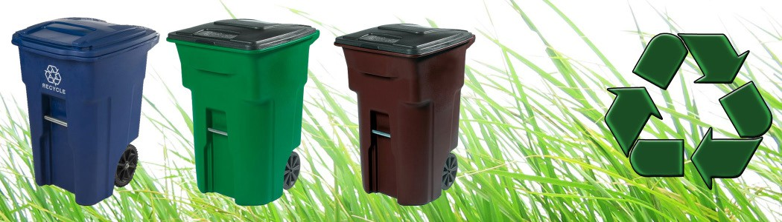

Professional Recyclers of Pennsylvania | www.proprecycles.org | 717.441.6049
Overnight Accommodations
Class Location & Details

Date:
May 22 -23, 2024
Time:
9:00 am - 4:30 pm (Both Days)
Class Location:
Centre County Recycling & Refuse Authority
253 Transfer Road
Bellefonte, PA 16823
Registration Fee:
Both Days:
$505 Member / $675 Non-Member
May 22 only:
$275 Member / $415 Non-Member
May 23 only:
$275 Member / $415 Non-Member
105 or 430 only:
$150 Member / $275 Non-Member

Country Inn & Suites State College

1357 East College Avenue

State College, PA 16801

Phone: 814-234-6000

Link to book your rooms
Course Overviews
Recycling 105 - Establishing & Enhancing a Recycling Program: Program Managers in both newly mandated communities and those with established programs will find this course valuable in helping to understand elements that build exceptional programs. Instructors will help participants understand the importance of tailoring a program to individual needs. Participants will see the value of a unified and comprehensive education program and examine the details of collection and processing.
Recycling 430 – Buying & Using Recycled/Waste Reduction and Reuse: This course provides practical, hands-on information for recycling officials, purchasing officials and using agencies on buying recycled products. This training program discusses the following topics: why buying recycled products is important, making a commitment to buy recycled, legislation and content standards, price, quality and availability of recycled products, specifications and testing and waste prevention.
Recycling 985 - Zero Waste: Zero waste businesses are leading the way for Zero Waste and have diverted over 90% of their waste from landfill and incineration. Zero waste communities have adopted zero waste goals and
plans to implement those goals. This course will demonstrate how zero waste can be a key part of community and business sustainability plans and help contribute to reducing greenhouse gases and global warming.

Who Should Attend
Municipal, county, state, and recycling and waste personnel from the commercial, public and private industries who are interested in recycling and those interested in obtaining or maintaining their certification.

Questions
For additional information, please contact Marcy Robey
mrobey@proprecycles.org | 717.441.6049 x 4
Register online at www.proprecycles.org

